K.P.C. PUBLIC SCHOOL, KHARGHAR
ASSESSMENT- V (2022-23)
GRADE : I MARKS : 40
SUBJECT: ENGLISH TIME : 2HRS
NAME : ____________________________________________

Q1 Read the poem extract carefully and answer the following questions. [5]

Thirty days has September,
April, June, and November.
All the rest have thirty- one,
Except February alone.
Questions
1. Which month is different from the rest?
Ans.___________________________.
2. How many days has June?
Ans.____________________________.
3. Write the meaning of the word “Except.”
Ans._______________________________________________________________.
4. How many days has December?
Ans.____________________________.
5. Write two pairs of rhyming words from the poem extract.
Ans.____________________________.
Q2. Seen passage [5]
They clapped their hands.
The eagle spread its big wings and flew away.
Rina made the ant climb onto a leaf
She left the leaf on the wall.
The ant saw a grain of sugar.
Based on your understanding of the passage , write True or False.
1. Rina made the ant climb onto a leaf. ___________.
2. The cat spread its big wings. ____________.
3. Children closed their hands. _____________.
4. She left the leaf on the wall . _____________.
5. The ant saw a grain of rice. ___________.
Q3. Give meanings and make proper sentences. [4]
1. Shadow- _____________________________________________________________________________
______________________________________________________________________________________
2.Limbs - ______________________________________________________________________________
______________________________________________________________________________________
Q4.Answer in one word. [5]
1. How many days does February have in a Leap year?
Ans: _______________________.
2.What did the children see when they set out to play?
Ans: _______________________.
3. “Let me fly”, - who said these words?
Ans: _______________________.
4. What did the two boys find?
Ans: _______________________.
5. Where did they land after the ride?
Ans: _______________________.
Q5. Answer the following [4]
1 What did the boy feel when he touched the carpet?
Ans: _______________________________________________________________________________
___________________________________________________________________________________
2. How are the baby and the birdie the same?
Ans: _______________________________________________________________________________
___________________________________________________________________________________
3. What did the children do to make the eagle fly away?
Ans: _______________________________________________________________________________
___________________________________________________________________________________
4. Write down the seven days of the week?
Ans: _______________________________________________________________________________
___________________________________________________________________________________
Q6. Do as directed (Grammar) [10]
1.Fill in the blanks with “and” or “but”.
1.I have a blue dress _____________ a pink belt.
2.The cow _____________the sheep are farm animals.
3The elephant is big __________ the rat is small.
4. I like to swim ___________ I don’t like to run.
2. Underline the correct conjunction.
1.I have a brother but / and a sister.
2. Ritu need a pencil but / and a paper.
3. Riya finished her work and / but Liya did not.
4.We played well and / but did not win the match.
3 Rearrange the words to make sentences. Use capital letters and fullstops.
1.Hard is ball the
Ans._______________________________________
2. Day is a it cold
Ans._______________________________________
4. Rewrite these sentences. Begin with capital letters and end with fullstops.

1. riya, rima and i went for a picnic
Ans.___________________________________________
2.the puppy is in a tub
Ans.___________________________________________
5. Write the antonyms
1.Clever x _________________
2. Alive x _________________
Q7. (Writing Skill) [7]
1.Write few lines about your favourite activity
Ans 1______________________________________________________________________________________2______________________________________________________________________________________3______________________________________________________________________________________4______________________________________________________________________________________
2. Picture Study :

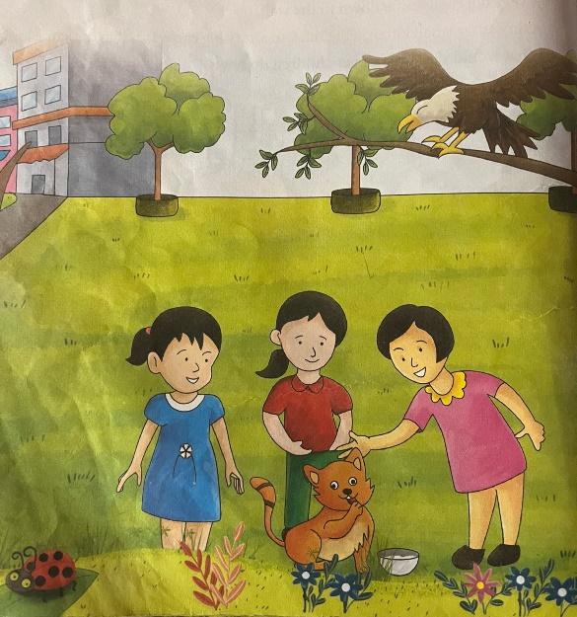
Look at the picture carefully and answer the following questions with the help of the words given below .
Playing with a cat , Eagle
Questions –
1.Name the bird.
Ans. _______________.
2.What are the children doing?
Ans._____________________________________________________________.
3.Complete the following lines of the poem
What does __________ baby say
In her bed at __________ of day?
Baby says, like little___________,
“Let me ___________ and fly away”

